**Airbus and Boeing: Super Jumbo Decisions**

**Prasad CVDK - 716200 Imtiaz Khan – 71620031**

**Venu Karadi - 71620084 Nikita Jaikar - 71620044**

**Objective:**

The objective of the case study is to assess the following:

* Whether Airbus and Boeing were right about the number of super jumbos that would be sold
* Should either company invest in the superjumbo project

**Key principles/considerations:**

Following are the key principles/considerations driving the simulation exercise:

* Market share in the VLA segment determined the attractiveness of the project for each company
* Super jumbo initial orders and deliveries-to-order ratio follow triangular distribution
* Simulate such that probability that NPV of the project after deducting the development costs is positive for both companies can be deduced and in turn the market share in the VLA segment

**Approach:**

The simulation is run for each of the following scenarios to assess the NPV and respective market shares.

* Only Airbus enters the superjumbo market
* Only Boeing enters the superjumbo market
* Both enter the superjumbo market

**Results:**

|  |  |  |  |
| --- | --- | --- | --- |
| **VLA Market Share representation – decision matrix** | | | |
| **Scenario** | **Airbus** | **Boeing** | **Remarks** |
| Only Airbus produces superjumbo | 50%* | 50% | Mean values of the market share. Probability that Airbus’s NPV for superjumbo is negative is 0.3% |
| Only Boeing produces superjumbo | 0% | 100% | Probability that Boeing’s NPV for superjumbo is negative is 15.6% |
| Both Airbus and Boeing Produce superjumbo | 34%* | 66%* | Mean values of the overall VLA market share. |

* *Note: VLA market shares and not superjumbo shares*

Taking into account labor constraints and given the likelihood that the superjumbo project can turn negative (NPV) is 15.6% for Boeing, it may decide not to launch. However, since the overriding factor is the **attractiveness** of market share it is in Boeing’s interest to launch the project as depicted in the table above. For Airbus, it is straight forward to launch the project as the project NPV will be negative with a probability of only 0.3%.

Given the market share scenario, recommendation for both companies is to produce super jumbos.

**Simulation Output:**

1. **Only Airbus produces Super Jumbo**

If only airbus produces super jumbo, initial order at the end of five years is **139.2833333** and net present value is **26561.875** which is produced after 5000 simulations with the total VLA market share of 50% with a probability of negative NPV at 0.3%

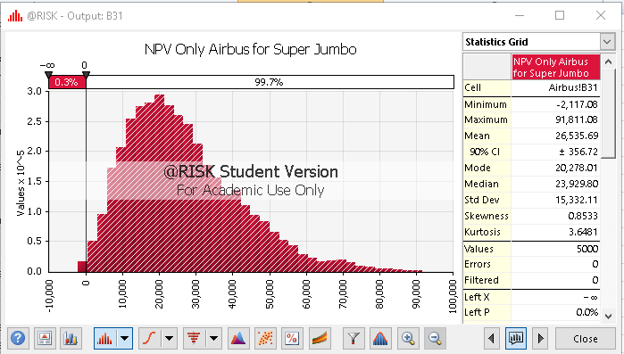

1. **Only Boeing produces Super Jumbo**

If only Boeing produces super jumbo, initial order at the end of five year is **77.83333333** and net present value is **47256.25** which is produced after 5000 simulations with the total market share is 100%. The probability that the NPV is negative is 15.6% as depicted in the picture below.

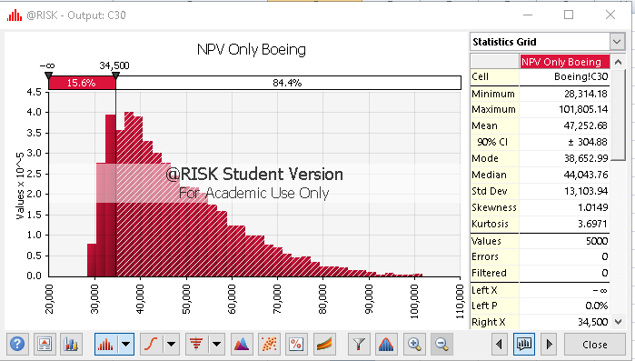

1. **Airbus and Boeing Produces Super Jumbo**

If Airbus and Boeing both produce super jumbo, then mean VLA market share Airbus and Boeing are approximately 34% and 66 % respectively.

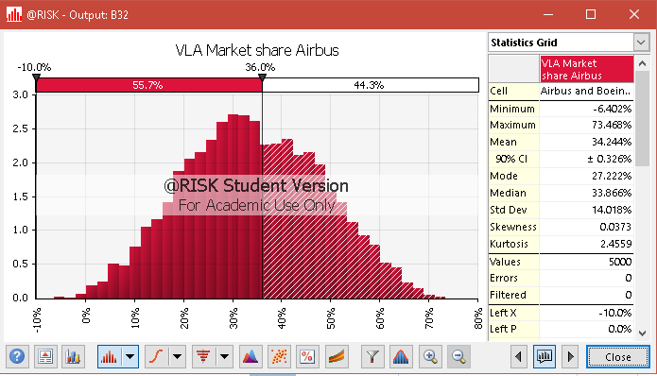

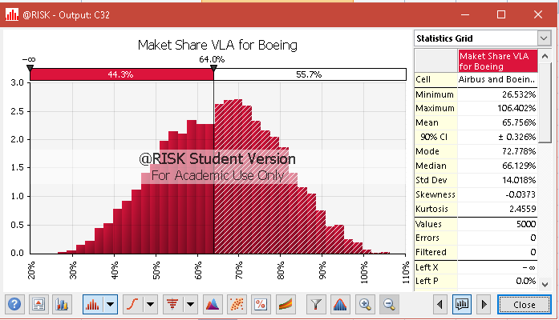

**Assumptions:**

|  |  |
| --- | --- |
| Airbus A3XX Development Cost | 10000.00 |
| Boeing 747-X development costs | 7500 |
| Airbus Present value of profit per VLA | 25 |
| Boeing present value of profit per VLA | 25 |
| Boeing savings from later 747-X development | 0.1 |
| Boeing 747-X share of superjumbo market | 0.4 |

**Appendix**

**Initial order distribution**

The Boeing forecast of initial super jumbo orders distribution is in the range of 10 to 200 planes with most likely being 23.5 planes

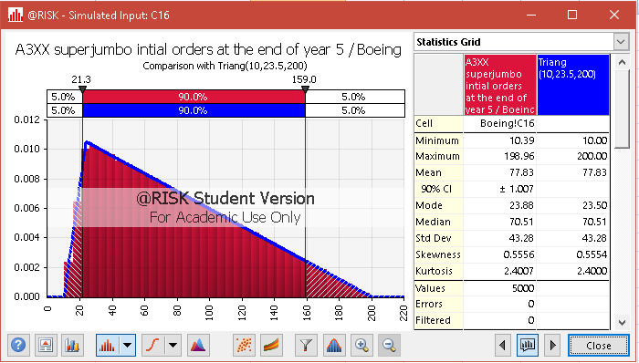

Airbus forecast of initial super jumbo orders distribution is in the range of 71.45 to 261.45 and most likely 84. 95

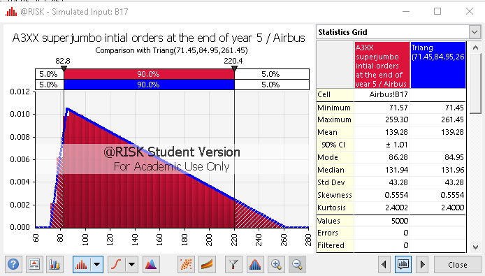

**Deliveries-to-order ratio**

The minimum ratio of annual super jumbo deliveries to the initial order would be in the range of 10% to 50% most likely 30%. Distribution is as follows for Boeing follows as Triangular distribution

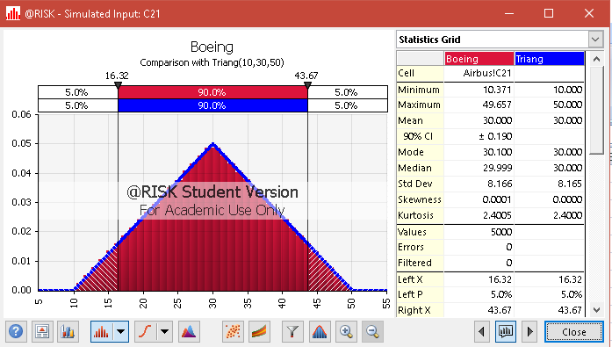

Same as the Airbus follows triangular too in the range of 10% to 50% and most likely 30%

